Investigating the Effect of Initial Velocity on Spacecraft Orbital Energy and Trajectory
Computational Physics Project | Python | Newtonian Orbital Mechanics

Abstract
A numerical two-body orbital model was developed in Python to investigate how initial spacecraft velocity affects orbital energy and trajectory around Earth. A spacecraft was placed at an altitude of 400 km and given tangential velocities between 1.00 and 1.42 times the circular orbital velocity. Newtonian gravity was integrated numerically using the velocity-Verlet method. Increasing initial velocity caused specific orbital energy and eccentricity to increase. At 1.40 times circular velocity the trajectory remained bound, while at 1.42 times circular velocity the model produced positive orbital energy and eccentricity greater than one, indicating an unbound trajectory. This brackets the theoretical escape ratio of sqrt(2), approximately 1.414.

1. Research Question
How does increasing the initial tangential velocity of a spacecraft from a 400 km Earth orbit affect its orbital energy, eccentricity and trajectory?

2. Background
For a small spacecraft orbiting Earth, the circular orbital speed at distance r is:
v_c = sqrt(GM/r)
The escape speed at the same distance is:
v_esc = sqrt(2GM/r) = sqrt(2) v_c
Specific orbital energy is:
epsilon = v²/2 - GM/r
Negative energy corresponds to a gravitationally bound trajectory; zero is the escape boundary; positive energy corresponds to an unbound trajectory. Eccentricity e = 0 represents a circle, 0 < e < 1 an ellipse, e = 1 the parabolic escape boundary, and e > 1 a hyperbolic trajectory.

3. Method
- Earth was represented as a central spherical mass of 5.97219 × 10²⁴ kg with radius 6.371 × 10⁶ m.
- The spacecraft began at 400 km altitude, giving an initial distance of approximately 6.771 × 10⁶ m from Earth's centre.
- The calculated circular velocity was approximately 7.673 km/s.
- Initial tangential velocities of 1.00, 1.05, 1.10, 1.20, 1.30, 1.40 and 1.42 times circular velocity were tested.
- The equations of motion were integrated numerically using velocity-Verlet integration.
- Specific orbital energy and eccentricity were calculated for each initial condition.

4. Results
Multiplier | Velocity (km/s) | Energy (J/kg) | Eccentricity | Classification
1.00 | 7.673 | -2.94e+07 | 0.000 | Circular
1.05 | 8.056 | -2.64e+07 | 0.103 | Elliptical
1.10 | 8.440 | -2.33e+07 | 0.210 | Elliptical
1.20 | 9.207 | -1.65e+07 | 0.440 | Elliptical
1.30 | 9.974 | -9.12e+06 | 0.690 | Elliptical
1.40 | 10.742 | -1.18e+06 | 0.960 | Elliptical
1.42 | 10.895 | 4.83e+05 | 1.016 | Escape
The results show a continuous increase in orbital energy and eccentricity. The transition occurs between 1.40× and 1.42× circular velocity: the former remains bound while the latter becomes unbound.
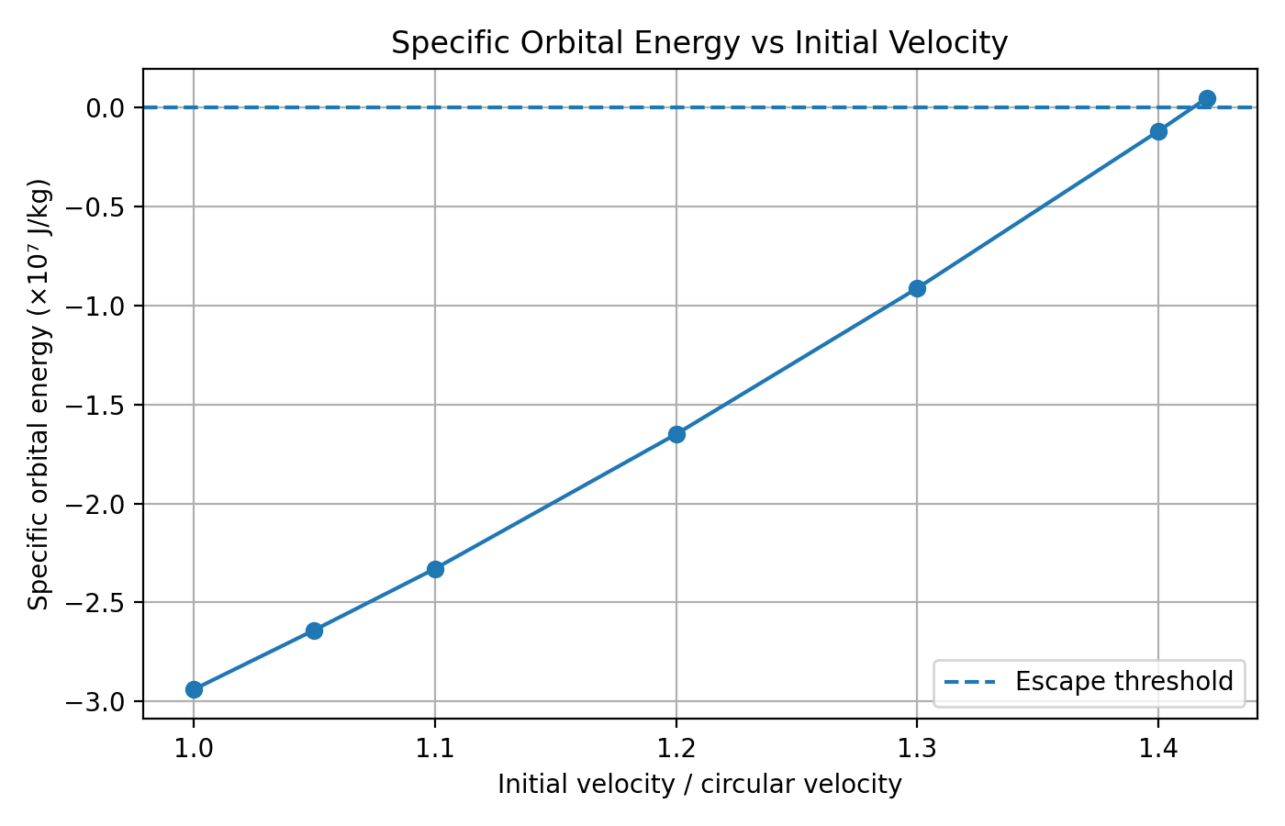
Figure 1. Specific orbital energy versus initial velocity.
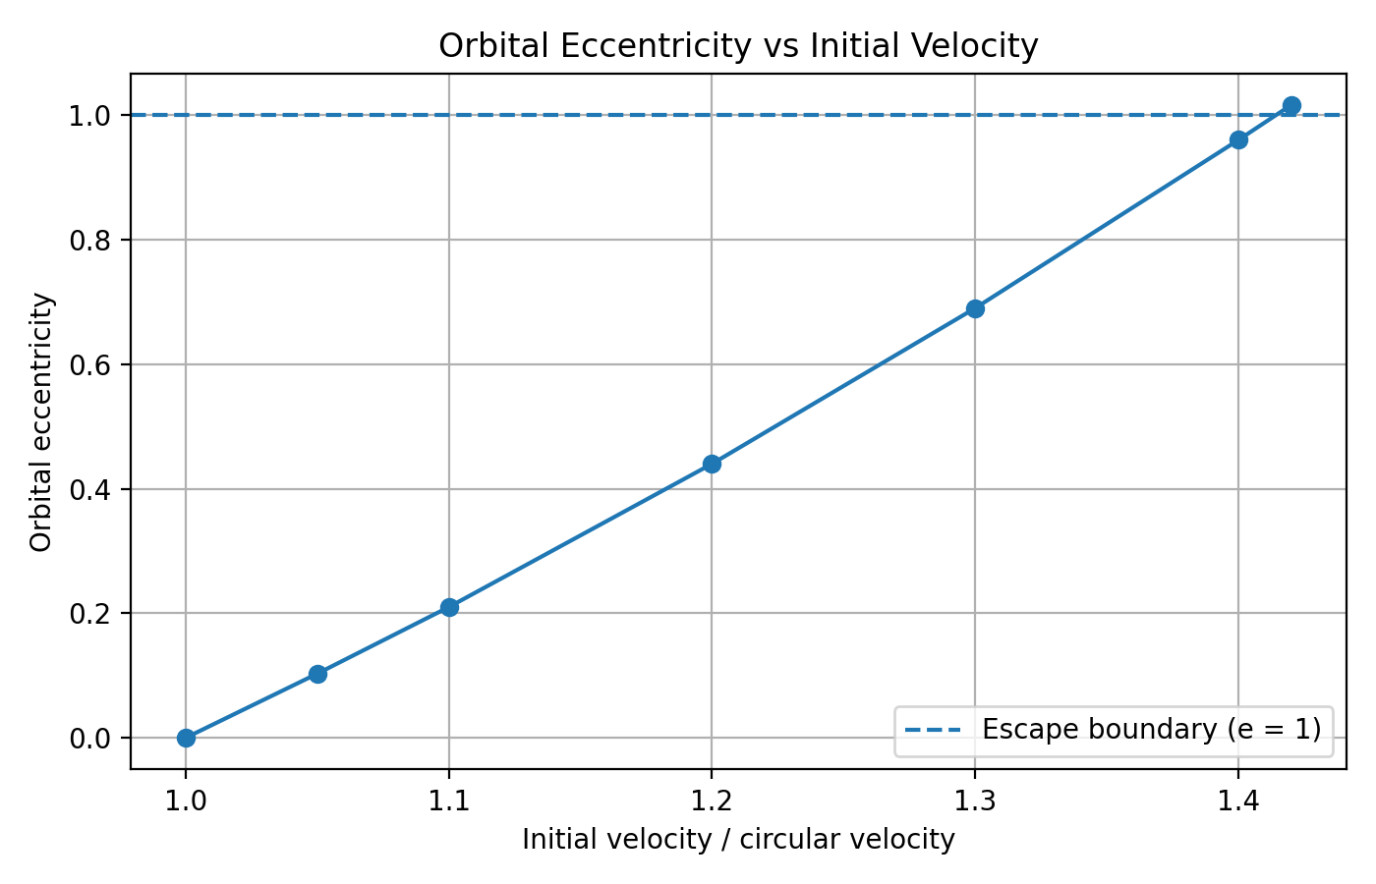
Figure 2. Orbital eccentricity versus initial velocity.

5. Discussion
The numerical result agrees with the theoretical escape ratio v_esc/v_c = sqrt(2) ≈ 1.414. The simulation brackets this value: 1.40× gives negative energy and e = 0.960, whereas 1.42× gives positive energy and e = 1.016. Increasing velocity therefore moves the system from a circular orbit through increasingly eccentric ellipses and then into an unbound trajectory.

6. Limitations
- The model uses Newtonian two-body gravity and ignores the Moon, Sun and other bodies.
- Atmospheric drag and Earth's non-spherical gravity field are neglected.
- Numerical integration introduces finite-step error.
- Rocket thrust, fuel use and real launch manoeuvres are not modelled.
- The plotted trajectory is limited to a finite simulation time.

7. Conclusion
The Python simulation demonstrates that initial velocity controls spacecraft orbital energy and trajectory. Increasing velocity produced progressively more eccentric bound orbits, with the transition to an unbound trajectory occurring between 1.40 and 1.42 times circular velocity. This is consistent with the theoretical escape ratio of approximately 1.414 and demonstrates the agreement between classical orbital mechanics and the numerical model.

8. Future Work
- Add atmospheric drag and investigate low-Earth-orbit decay.
- Implement Hohmann transfers between circular orbits.
- Compare numerical integration methods and quantify numerical error.
- Add Earth's J2 gravitational perturbation.
- Extend the model to include the Moon.

References
OpenStax, University Physics Volume 1, Chapter 13: Gravitational Potential Energy and Total Energy; Satellite Orbits and Energy.
NASA/JPL, Fundamentals of Orbital Mechanics, Chapter 7: Orbital Mechanics.

